A1340-AM,S-Peru-South Coast-Tiahuanaco-Huari Style-Face-600-1000 CE

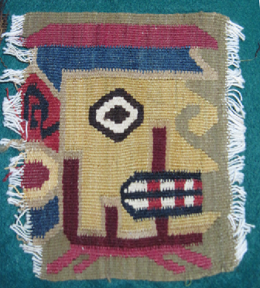

Fig. 1. Peru-South Coast-Tiahuanaco-Huari Style-Face-600-1000 CE

**Case no.: 7**

**Accession Number: A1337**

**Formal Label:** Peru-South Coast-Tiahuanaco-Huari Style-Face-600-1000 CE

**Display Description:**

This abstract textile mask of the Tiahuanaco-Huari style encompasses abstract designs composed of juxtaposed elements -- eyes, nose, and teeth -- that are arranged in rectangular compartments. Apparently, the horizontal division of the eye element and the teeth element suggests that it is of a deceased person. This disintegration of an entire figure into a mosaic of abstract elements of the face alone is one of the most fascinating developments in Andean art in which the particular stands for the whole. This square was probably part of a large rectangular panel similar to one from the South Coast, Tiahuanaco-Huari Style, 600-1000 CE.

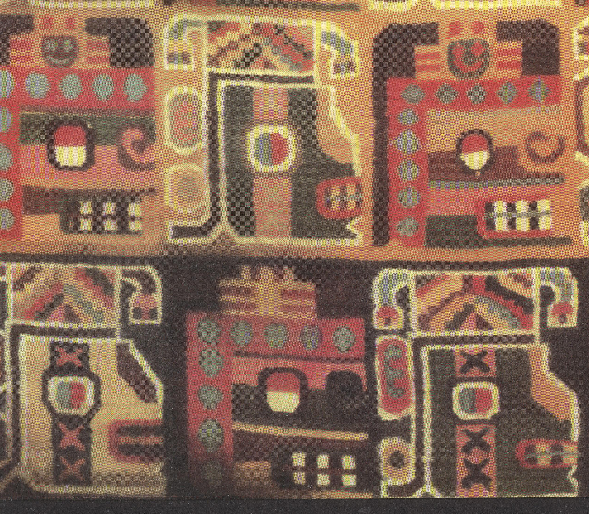 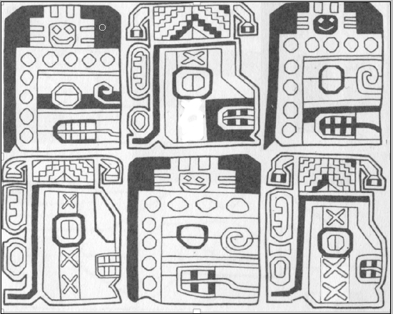

**Fig. 2.** Detail from alarge panel from the South Coast, Tiahuanaco-Huari Style, 600-1000 CEfromAnton 1987.

**Fig. 3** Elements 2 and 6 counting from the upper left to the right have been corrected from Anton, Fig. 59 which is erroneous. The “X’s” below the vertically divided eyes indicate living beings with tear marks, which are physiological indications of having had mind-altering visions. In North America this experience is indicated by the **falcon-eye** or **weeping-eye motif**:

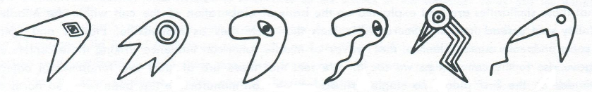

**Fig. 4.** Eye markings of the Southeastern Ceremonial Cult derived from the Peregrine Falcon. From https://peachstatearchaeologicalsociety.org/images/stories/Ceremonialpoints/forked%20eye%20scc.jpg

**LC Classification:** F3319.1.T55

**Date or Time Horizon:** 600-1000 CE

**Geographical Area:** Tiahuanaco, Bolivia.

**Map, GPS coordinates: 16º33'15.15" S 68º40'41.65" W**

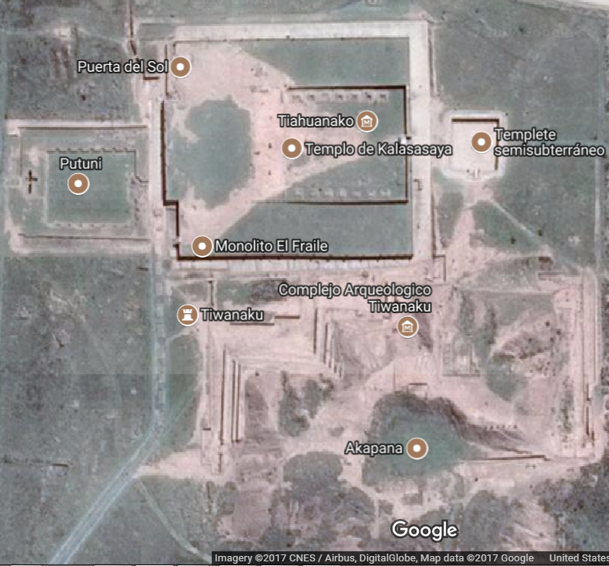

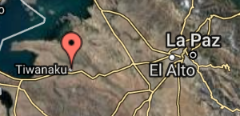

**Cultural Affiliation:** Tiahuanaco-Huari

**Media:** wool, vegetable dyes

**Dimensions:** various

**Weight: various**

**Condition: original**

**Provenance:** old New York Estate

**Discussion:**

This square was probably part of a large rectangular panel similar to one from the South Coast, Tiahuanaco-Huari Style, 600-1000 CE.

**References:**

Protzen, Jean-Pierre. 2013. The stones of Tiahuanaco: a study of architecture and construction. Los Angeles : Cotsen Institute of Archaeology Press, University of California, Los Angeles